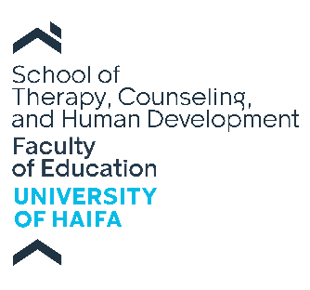

APPLICATION FORM (2026-2027)
MA Program in Education and Development in Early Childhood
Pease type (no handwriting)

Instructions:

The following items must be fully completed and submitted via the following link.
- Official Transcript and Undergraduate diploma - submit an un-official transcript and a copy of your undergraduate diploma (i.e., Bachelor's diploma) from the institution of higher education attended.
- Statement of Purpose- type and submit a statement of purpose (500 words). State your specific interests with respect to the international MA program in Education and Development in Early Childhood, your career objectives, intended area of specialization, and research interests and experience that are of particular interest.
- Personal History Statement - Type and submit a personal history statement (500 words). Please discuss how your personal background informs your decision to pursue a graduate degree in Education and Development in Early Childhood. You may include professional, educational or personal experience, challenges, or opportunities relevant to your decision.

NOTE: all required documents MUST be sent in one package.
Please do not submit your application with partial documents! Thanks

Please type clearly (no handwriting):

Name (First, Middle, Last): ______________________________________________________________________

Date of Birth: ________________ Gender (Male/Female): _____________

Country of Birth: ________________ Citizenship (if different than Country of Birth): ________________

Marital Status: ________________

Number of Children: ________________ Age of Children: ________________

If you are expecting a baby, what is the estimated birth date? ________________

How did you learn about this program? Please describe: ______________________________________________
___________________________________________________________________________________________
Home Address: ______________________________________________________________________________

City ________________ Country ________________ Zip ________________

Cell Phone #: ________________________________WhatsApp #: _______________________

Current Address and Phone Valid Until: ___________________________________________________________

E-mail: ________________________________________________

Social Security/ID Number: _________________________ Israeli ID number (where applicable): ______________

Passport Number: ______________________________ Expiration Date: _________________

Colleges and/or Universities attended (list of recent first):

Name of Institutions
and Departments: Location: Period of Study: Degree: Final Grade (GPA):

___________________ _______________ ______________ ____________ __________

___________________ _______________ ______________ ____________ __________

___________________ _______________ ______________ ____________ __________

Employment and Professional Activities:
Please list any recent jobs and occupations, particularly those that involve working with children and or families:

Place of Work/Activity: Dates: Job/Activity Description:

____________________________________________________________________________________

____________________________________________________________________________________

____________________________________________________________________________________

Number of years working with Children: ____________

University of Haifa | School of Therapy, Counseling and Human Development
הר הכרמל, חיפה. ת.ד. 3338 | טלפון: ,04-8249726 פקס: 04-8288008
Tel: +972- 4-8249726 Fax: +972-4-8288008
199 Abba Khoushy Ave., Mount Carmel, Room 437, Haifa, 3103301. POB: 3338, Israel
https://edu.haifa.ac.il/counseling

